# Introduction

The assignment is targeted to test the skills of the candidate in CSS.

# Objective

This assignment will help master the concepts of CSS.

# Pre-requisites

Concepts of HTML.

# Associated Data Files

Not Applicable

# Problem Statement

1. Create one form having registration and student login fields for course.

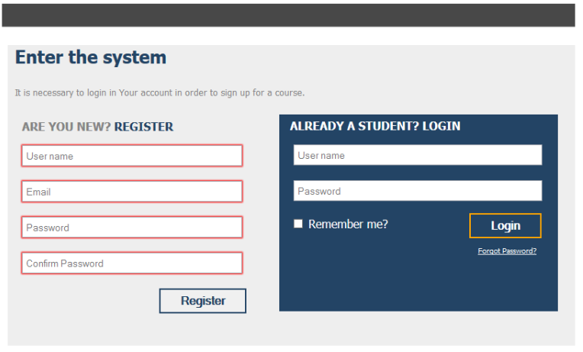

1. Create one html file,

* There will be one main page that hold login and signup button.
* Once user will click one signup button , it will open signup module with this fields –name , email ,password
* And then user can go back in main page . and user can try login with email and password . if email and password will correct than user will redirect to home page
* If email and password is incorrect than it will show error message .
* And in home page you have to show some message like – welcome to “username”. With logout button .
* And once user will click on logout , user will redirect to main page

1. Create one form having following fields
   1. Email ( with html5 email validation).
   2. Password (It should take minimum 6 charactors ).
   3. Your project URL ( with html5 url validation).
   4. Project completion date ( with html5 date validation).
   5. Current month ( with html5 month validation).
   6. Current week (with html5 week validation).
   7. Current time (with html5 time validation).
   8. Select color (with html5 color features).
   9. Age (with html5 range features and also show the selected age ).
   10. Your hobbies (with html5 data list )